**General Skills**

1

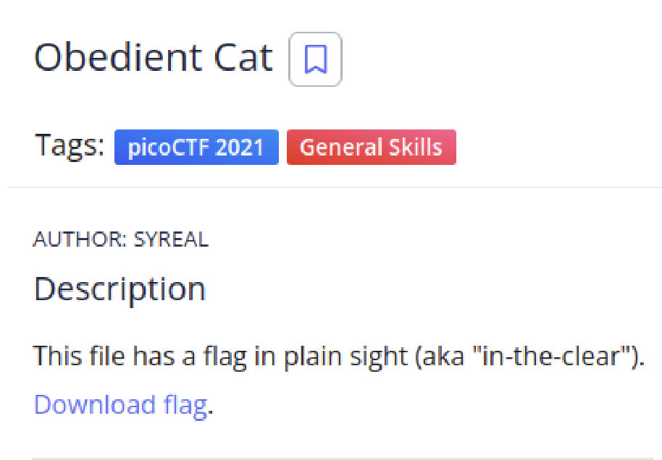

Solution

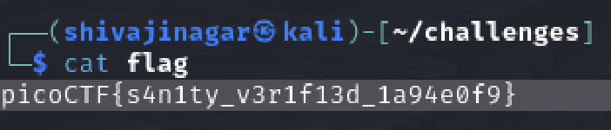

Using the cat command, we find the flag.

2.



Solution

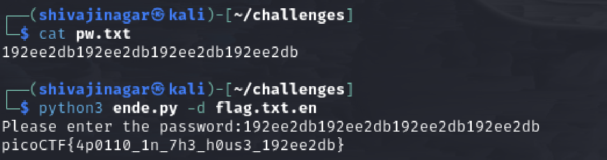

Running the python script with the flag file and using the password, we get the flag.

3.



Solution



Using the strings command gives the flag.

4.

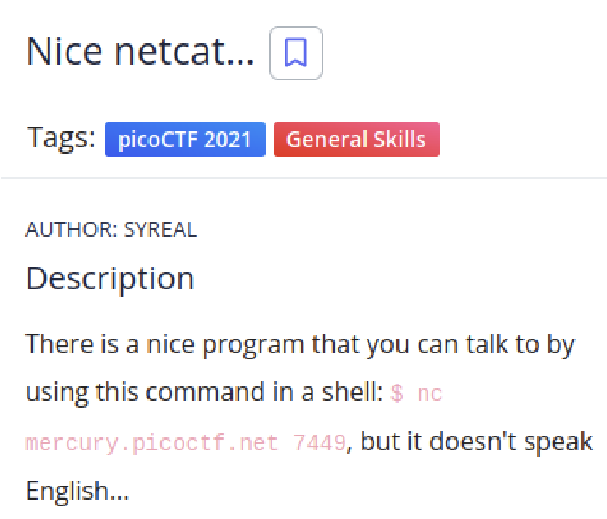

Solution



Using the command in the problem statement, we have the following ASCII numbers. Using an online converter to convert ASCII to text, we have the flag.



5.

Solution

Using an online converter, we have the flag.

6.

Solution

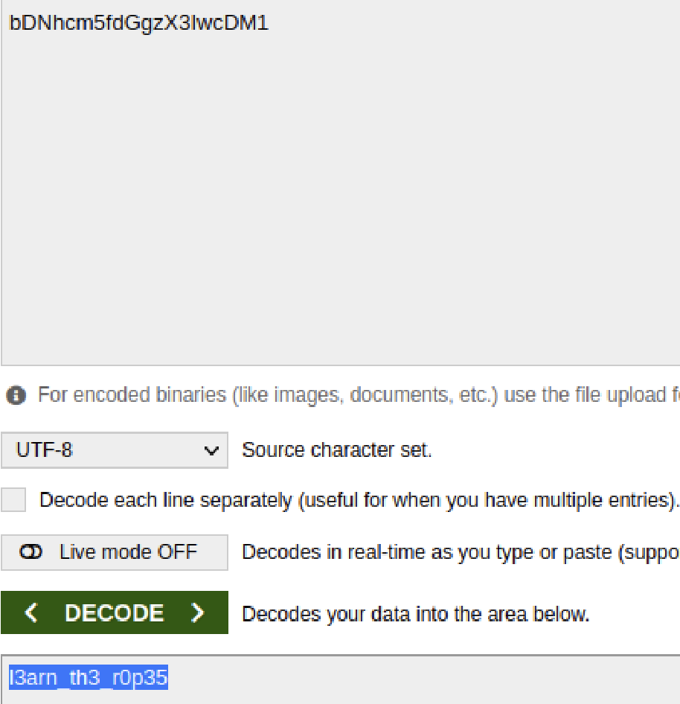

Using an online base64 decoder, we have the flag.

7.



Solution

The flag is easily found using grep